Instructions for installing Laravel

Simeon Markov

**Date: 2024-04-24**

1. **Server Requirements**

* **Laravel version depends on the php version. For more information check** [**Laravel’s documentation**](https://laravel.com/docs/11.x/releases#support-policy)
* Mcrypt PHP Extension
* OpenSSL PHP Extension
* Mbstring PHP Extension
* Tokenizer PHP Extension

1. **Installation**

! Ensure smooth integration with other libraries and PHP versions by verifying that your chosen version of Laravel is compatible with your project’s dependencies.

1. **Install XAMPP:** Navigate to <https://www.apachefriends.org/> and follow the steps. **It is recommended to install the latest version**. During the installation process, you can choose which components to install. **Make sure to select PHP and MySQL**.
2. **Install Composer:** Navigate to <https://getcomposer.org/download/> and follow the steps.
3. **Verify Composer Installation:** Open the Command Prompt and run the following command: composer --version.
4. **Installing Laravel via composer**

**Note:** In this example, we are installing the latest version of Laravel (Laravel 11) and it requires a minimum PHP version of 8.2 to this date.

1. **Go to php installation:** Navigate to the **php.ini file.**

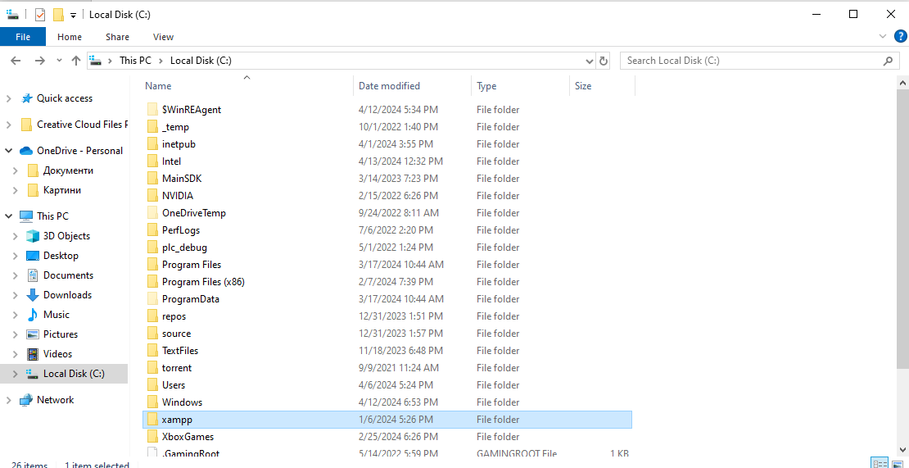

**Note:** The exact location of your php.ini may vary.

1. **Un-comment the following:** extension=zip, extension=fileinfo, extension=openssl, extension=pdo_mysql. **For example:**

Delete the comma in front of it.

1. **Add composer to environment variable:**

Note:** The location and the file name may vary.

Copy the path.

Paste your path.

1. **Open the command prompt**

* **A screenshot of a computer program

  Description automatically generatedType the command: composer global require laravel/installer**

**If you encounter an error during the installation process, you may want to check the php.ini in the xampp control panel and un-comment the following:** extension=zip, extension=fileinfo, extension=openssl, extension=pdo_mysql**:**

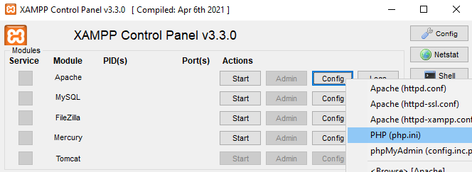

1. **Setting up Laravel**
2. Open VS Code: When it is opened, navigate to the xampp\htdocs folder:

You can create your own folder.

1. Open the terminal and type: laravel new [Project Name].

1. The setup process will begin.
2. You will be prompted to choose a starter kit:

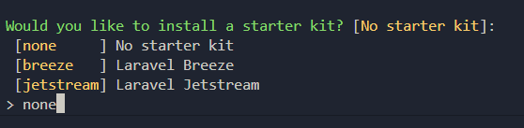

1. You will be prompted to choose a testing framework. In this case, we will continue with the default one:

1. And afterward you will need to choose a database:

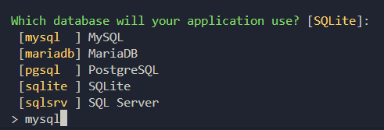

1. At the end you will be asked if you would like to run a database migration:
2. Now you can check the homepage of Laravel by navigating to http://localhost:8080/dashboard/Laravel/FirstLaravelWebSite/public/.

